Epiphyte Electronic Hardware Description

Overview
This document serves as a reference for the electronic hardware elements of the first prototype of Epiphyte. The design evolved as it was built, and I offer suggestions for improvement or modifications as appropriate.
In the interest of brevity, it is assumed that the reader is already familiar with electronics and programming.

Epiphyte System
The overall design of the Epiphyte system is shown in Figure 1, below, with a focus on the elements to be described in this document.
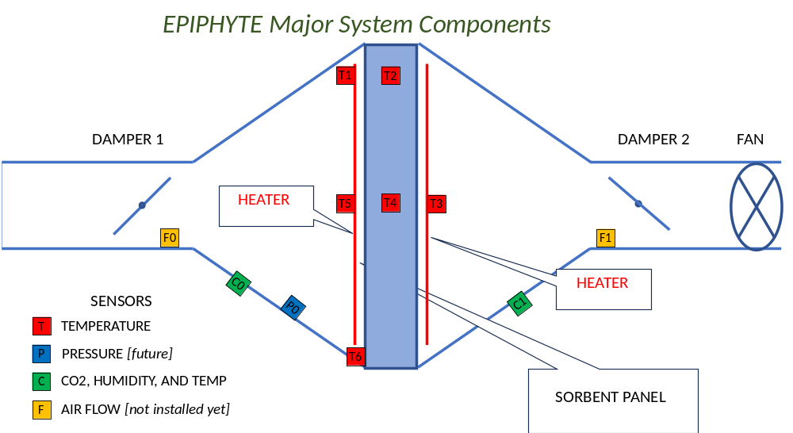
Figure 1: Epiphyte System

Electronics Block Diagram
To put the detailed description that follows into context, Figure 2 shows a high-level block diagram of Epiphyte’s electrical circuitry.
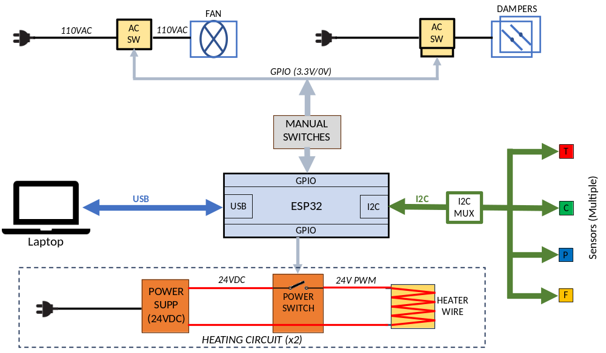
Figure 2: Epiphyte Electrical Block Diagram

Processor
The processor is an Adafruit ESP32 Feather V2. Most other processors should work, as the application is not critical for speed or complex calculations. In particular, most 3.3-V processors of the Arduino or Adafruit Feather family should work with a few changes to the software.
The processor also includes WiFi and Bluetooth connectivity, but these features have not been employed with Epiphyte as of this writing. They might be useful for data logging onto a server, or for remote control and monitoring of the system.
The user is urged to read and understand the information provided by Adafruit here: https://learn.adafruit.com/adafruit-esp32-feather-v2
The Feather can be programmed either in C/C++ or Python. In Epiphyte, I used C/C++.

Pinout
Figure 3 shows the top and bottom sides of the Adafruit ESP32 Feather, with the pins labelled. Figure 4 is a detailed view showing all the possible functions and labels of each pin.
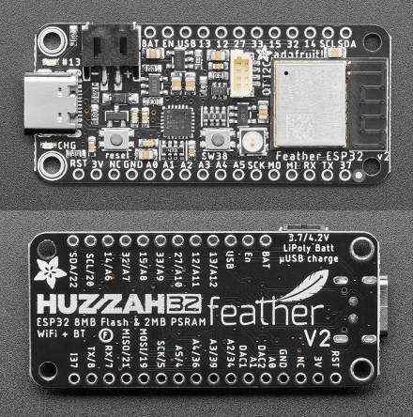
Figure 3: Adafruit ESP32 Circuit Board
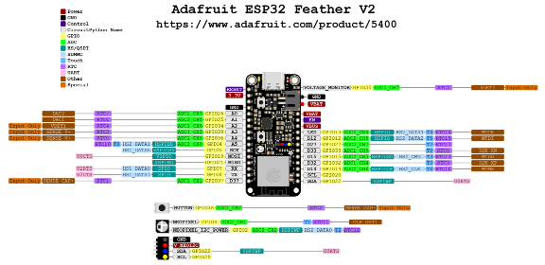
Figure 4: Adafruit ESP32 Pinout

Display
For realtime monitoring of system activity, a monochrome OLED display is provided. This Adafruit “Feather Wing” can be attached to the Feather processor. All connections are made through pins without needing any additional wiring.
Communication with the display is via I2C, and this board also includes three pushbutton switches that are connected to processor GPIO pins.
https://www.adafruit.com/product/4650

Neopixel
An RGB LED (“Neopixel”) is supplied on the Feather board. This LED’s color and brightness can be programmed and used as a visual indicator. The NeoPixel library handles all the programming of this device.

Processor Pin assignments
Table 1 below shows the GPIO pins that are used in this design. Functions are detailed in sections below.
Pin No | Signal | In/Out | Description
0 | NEOPIXEL_PIN | O | Serial communication with NeoPixel
12 | swRUN | I | To toggle switch: active LOW sets RUN mode
13 | swSET | I | To toggle switch: active LOW sets SETUP mode
14 | BUTTON_C | I | To OLED board pushbutton C (not used)
15 | BUTTON_A | I | To OLED board pushbutton A (not used)
27 | HEAT_PWM_1 | O | To Heater 1 control gate; PWM duty-cycle control
32 | BUTTON_B | I | To OLED board pushbutton A (not used)
33 | HEAT_PWM_2 | O | To Heater 2 control gate; PWM duty-cycle control
Table 1: Processor GPIO Pin Assignment

I2C Connections
The sensors in Epiphyte are all connected to the processor with the I2C serial bus. It is important to note that because the processor supply and interfaces are 3.3V, any slave devices must also operate from this voltage (including pullups) to avoid damaging the processor.

STEMMA QT
STEMMA QT is an Adafruit system for easily making I2C connections between compatible devices. Many boards come with a STEMMA QT connector, and cables of various lengths are available to connect devices simply by plugging in the cables.
Each cable has 4 wires: Power, Ground, SDA, and SCK. Cables come in various lengths; an example is depicted in Figure 5.
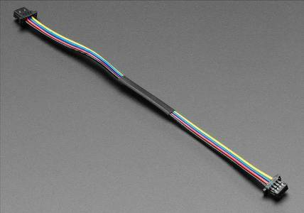
Figure 5: Example STEMMA QT Cable

I2C Extender
I2C signals suffer degradation with longer cables (including STEMMA QT cables). The I2C extender allows cascades of STEMMA QT cables or longer runs between the processor and the sensors. The LTC4311 is an IC which boosts and reshapes I2C signals, and is available from Adafruit on a breakout board with convenient STEMMA QT connectors. This device is liberally used in Epiphyte wherever longer signal runs are needed.
https://www.adafruit.com/product/4756

I2C Multiplexing
Because there are multiple instances of each type of sensor, most with fixed I2C addresses, a multiplexer is necessary to disambiguate these devices for correct addressing. Adafruit makes a breakout board for the PCA9548 I2C multiplexer chip (Figure 6), which features a common port on the end and eight switched ports around two edges, all with STEMMA QT connectors.
https://www.adafruit.com/product/5626
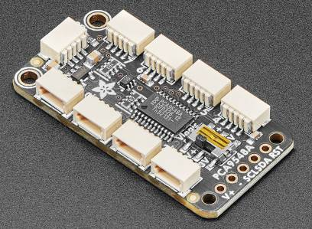
Figure 6: Adafruit 1:8 MUX Breakout Board
The MUX acts as a bidirectional 1-to-8 switch, and is itself an I2C device with its own address. The I2C address of the MUX can be selected with solderable jumpers on the PCB (labelled A0, A1, and A2 on the back in Figure 7). The position of the switch is controlled by the processor sending a formatted command. Then the MUX becomes transparent and the selected slave device can be addressed in the usual way as if it were the only one on the bus with that address. Note that the ports are numbered 0 through 7.
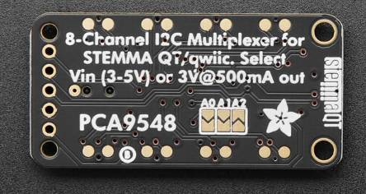
Figure 7: MUX breakout board, back side
In the current embodiment of Epiphyte, two 1:8 MUXes are used, with labels as used in the software and corresponding addresses as follows:
MUX Label | MUX I2C Address
MUX1 | 0x71
MUX2 | 0x72

Table 2 shows the MUX addresses and port numbers of each sensor used in Epiphyte. The connections are shown schematically in Figure 8.
Device | Part No. | Label | MUX# | MUX Channel | Device I2C Address | Location
Thermocouple Amp | MCP9600 | T0 | 2 | 0 | 0x67 | Not used
Thermocouple Amp | MCP9600 | T1 | 2 | 1 | 0x67 | Input side heater wire, corner
Thermocouple Amp | MCP9600 | T2 | 2 | 2 | 0x67 | Sorbent center, corner
Thermocouple Amp | MCP9600 | T3 | 2 | 3 | 0x67 | Output side heater wire, center
Thermocouple Amp | MCP9600 | T4 | 2 | 4 | 0x67 | Sorbent center, center
Thermocouple Amp | MCP9600 | T5 | 2 | 5 | 0x67 | Input side heater wire, center
Thermocouple Amp | MCP9600 | T6 | 2 | 6 | 0x67 | Sorbent frame
Thermocouple Amp | MCP9600 | T7 | 2 | 7 | 0x67 | Not used
CO2 Sensor | SCD30 | C0 | 1 | 3 | 0x61 | Input duct
CO2 Sensor | SCD30 | C1 | 1 | 4 | 0x61 | Output duct
Pressure Sensor | MPRLS | P0 | 1 | 5 | 0x18 | Not used (yet)
Flow meter | FS1015-1005 | F0 | 1 | 2 | 0x50 | Not used (yet)
Flow meter | FS1015-1005 | F1 | 1 | 1 | 0x50 | Not used (yet)
Table 2: I2C MUX Configuration

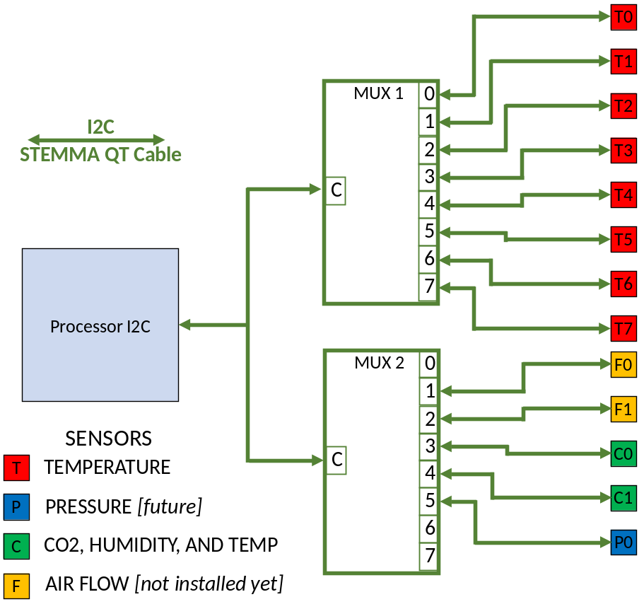
Figure 8: Sensor I2C Connectivity
Note: there is one simplification made on this diagram that should be noted. For connecting the Airflow Sensors, which require a 5-V power supply, a Logic Level Shifter is required to shift the 3.3-V I2C levels to the 5-V system.

Logic Level Shifter
https://www.adafruit.com/product/757
The logic level shifter is pretty flexible in that it can shift logic levels between any two voltages that are supplied to it. In Epiphyte, pin “LV” is connected to 3.3V, and the I2C SDA and SCL lines from the MUX that control the Airflow Sensors are connected to pins A1 through A4; “HV” is powered from 5V (from the Feather USB pin) and pins B1 through B4 go to the I2C pins of the two Airflow Sensors.

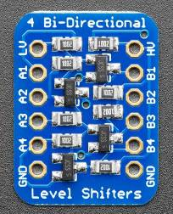

Control Switches
A number of toggle switches are provided for manually controlling the state of the executing software and to control the fan and dampers.

Heating System
Two heating systems are supplied, one for each side of the sorbent. The details of this system will vary greatly depending on the amount of heat needed by the sorbent, the location of the wires, the heat loss from parasitic conduction, and the size of the sorbent panel.

Nichrome Wires

Power supply

PWM Switching Circuit
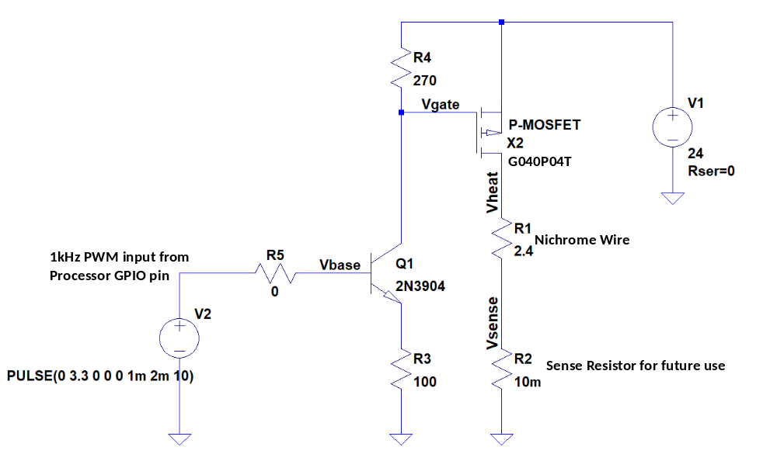

Mechanical Controls

Fans

Damper

Sensors

CO2 Sensors

Temperature Sensors and Amplifiers
https://www.adafruit.com/product/4101

Pressure Sensors
https://www.adafruit.com/product/3965

Airflow Sensors
https://www.mouser.com/ProductDetail/972-FS10151005
Note: this part is shown as “obsolete” so a replacement will need to be found.

